**The [LOCATION REDACTED] Interviews - John Schindler: Schindler's Hit List**

What Everyone Got Wrong About "Trump-Russia", Ukraine's Future, The Chinese "Threat", Public Trust/US Decline, Balkan Experiences, How To Torture Glenn Greenwald

24 SEPT 2023

[[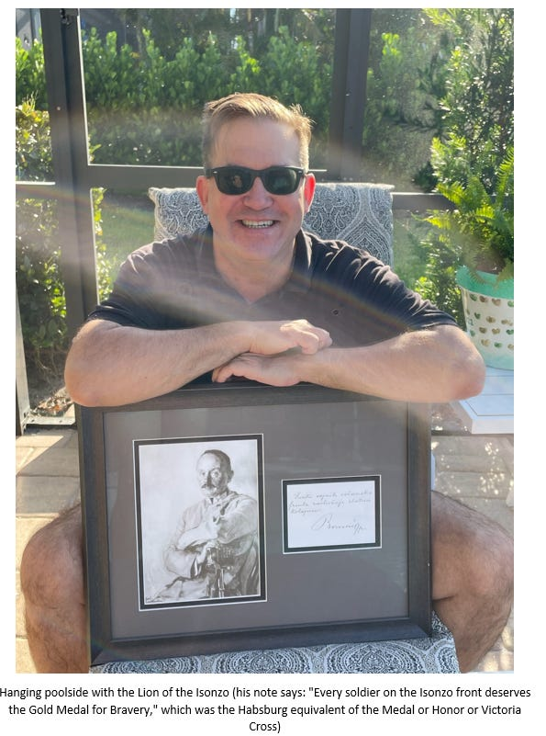](https://substackcdn.com/image/fetch/f_auto,q_auto:good,fl_progressive:steep/https%3A%2F%2Fsubstack-post-media.s3.amazonaws.com%2Fpublic%2Fimages%2F66bdd509-a019-491b-b475-54805449910d_595x801.png)](https://substackcdn.com/image/fetch/f_auto,q_auto:good,fl_progressive:steep/https%3A%2F%2Fsubstack-post-media.s3.amazonaws.com%2Fpublic%2Fimages%2F66bdd509-a019-491b-b475-54805449910d_595x801.png" \t "_blank)

Bottom of Form

[***John Schindler***](https://topsecretumbra.substack.com/)*is a*[***best-selling author***](https://www.amazon.co.uk/John-R-Schindler/e/B001HCXXZY/ref=zg_bs_g_882498_bl_sccl_30/000-0000000-0000000)*and an ex-NSA Intelligence Analyst and Counterintelligence Officer who specialized in counterespionage and counterterrorism, with operational experience in Eastern Europe and the Middle East. For almost a decade now, I have been reading his books and following him on social media, where I have acquired a great admiration for his knowledge of not just espionage, but history as well. I recently asked him to sit for an interview with me, and this was initial response:*

*What the fuck did you just fucking say about me, you little bitch? I’ll have you know I graduated top of my class in the NSA, and I’ve been involved in secret raids on Al-Qaeda, and I have over 300 confirmed kills. I am trained in gorilla warfare and I’m the top sniper in the entire US Intel Community. You are nothing to me but just another target. I will wipe you out with precision the likes of which has never been seen before on this Earth, mark my words. You think you can get away with saying shit to me over the Internet? Think again, fucker. As we speak I am contacting my network of spies across the USA and your IP is being traced right now so you better prepare for the storm, maggot. The storm that wipes out the pathetic little thing you call your life. You’re fucking dead, kid. I can be anywhere, anytime, and I can kill you in over seven hundred ways, and that’s just with my bare hands. Not only am I extensively trained in unarmed combat, but I have access to the entire arsenal of the United States Marine Corps and I will use it to its full extent to wipe your ass off the face of the continent, you little shit. If only you could have known what unholy retribution your little “clever” comment was about to bring down upon you, maybe you would have held your tongue. You didn’t, and now you’re paying the price, you goddamn idiot. I will shit all over you and you will drown in it. You’re fucking dead, kiddo.*

*By the time he sobered up the next morning (still in his hot tub from the night before), I asked him again and he told me that he was “more than eager” to do this interview, and was wondering why I had never asked him prior to that.*

**Despite your years of CIA training, I am certain that I could kill you with my bare hands if given the opportunity to do so (I’d love to do it).**

Doubtful. I have this spook look that nullifies resistance. It’s like Zoolander’s “Blue Steel,” but highly classified. It freezes opponents.

If that fails, I’ve done martial arts for years. More relevant: I’m heavily armed. Florida lets anybody have a concealed carry permit. I collect AK-47s (the M-70 is my favorite, but you could guess that). When COVID-19 hit, I bought a lot of 7.62 x 39, just because.

Come at me.

**You gained quite a lot of prominence during the**[**Snowden Affair**](https://nsarchive2.gwu.edu/NSAEBB/NSAEBB436/)**, engaging in running battles with his defenders, highlighting that national security and espionage are not as black and white as people would like them to be. In fact, it can never be. Your feelings about**[**Edward Snowden**](https://www.theguardian.com/us-news/2023/jun/08/no-regrets-says-edward-snowden-after-10-years-in-exile)**are well-known, but it would be interesting to hear your thoughts on the journalist who broke the story, Glenn Greenwald. Even more interesting (at least to me) would be what you would have done if you had custody of Glenn during that time. Let's imagine an extraordinary rendition took place via Poland, and you had to "de-brief" him. Which body part of his would you hit first with your fists? Would he be worth waterboarding? How long do you estimate that he would break and admit to working for Moscow, in your professional opinion?**

Glenn would break pretty fast. He looks rather doughy. However, he seems like the kind of guy who might enjoy getting punched, so I wouldn’t go there. He might just ask for more….which would get weird, fast. Waterboarding is a lot less exciting than it sounds, merely torture-lite. It doesn’t work particularly well.

If you really want to break someone, hand him over to our Middle Eastern partners, in particular one spy service that’s well known in spook circles for throwing suspects out of helicopters just for fun and pulling fingernails out with pliers. When a new guy arrives for “treatment” they greet him with: “Welcome, Brother – here there is no Allah and no Amnesty International!”

That’s more effective, really. Though the Poles are no slouches either. They can be an ornery bunch, and they’re not very fond of Kremlin suck-ups like Glenn, so I might just hand him over to Janek and Jurek after they’re well lubricated with wódka and let them have at for a few hours. Outsourcing is more deniable anyway.

**My personal best practice when it comes to the very secretive world of espionage and intelligence is to cast a very wide net in terms of sources in order to be able to compare and contrast reports and claims, and use them to decipher what could be as close to the actual truth as humanly possible. That's why I have three go-to sources upon whom I rely and who I trust to give me solid information. From the right, it's Mike Baxter of**[**Real Raw News**](https://realrawnews.com/)**. He broke the story of**[**Tom Hanks' execution**](https://realrawnews.com/2021/07/military-executes-tom-hanks/)**by the patriot faction in the US Military. From the other side of the political aisle it's**[**Louise Mensch**](https://twitter.com/LouiseMensch)**. Not for a second would I have thought that Steve Bannon would also be executed (in fact, his execution pre-dates Hanks' by four years). That**[**huge exclusive**](https://www.thecut.com/2018/11/i-think-about-this-a-lot-louise-mensch-steve-bannon-tweet.html)**is where she made her bones. You are located between the two of them, and are more guarded and not as willing to stick your neck out as they have been. Despite this relative cowardice, I still feel that you do provide some value on these subjects.**

I try, I really do.

**Your notoriety has made you a love/hate figure on social media. People want to know why you entered the world of national security and covert ops. Was it a sense of duty? A propensity for action and thrill? Could it have been the result of the pleasure of holding secret information above the heads of others like**[**Damocles' Sword**](https://dictionary.cambridge.org/dictionary/english/sword-of-damocles)**? Why did you go spook?**

I never intended to become a spook. Both my parents were career Intelligence Community officers aka “lifers”. I was “born with clearances” as they say in IC circles. I got my first security briefing from my dad (“Don’t tell the neighbors where we work” etc.) at age seven. Like all teenagers, I considered my parents to be boring squares, so the intelligence career path possessed no attraction for me at all.

However, I’m good with languages, and I was hanging around the Balkans back when that was messy (more on that shortly), and one day a mysterious recruiter called me, claiming to be from some humdrum U.S. Government outfit. Having grown up in spook circles I knew this was a bullshit cover story. But when the recruiter mentioned the salary, I listened. At that point, my alternative was some horrible, soul-crushing career in academia, so I took the bait. The rest is history and all that.

**One of the (admittedly) many things that I have learned from you over the years is that where the Soviets/Russians have historically excelled is in HUMINT (Human Intelligence). Examples include The**[**Cambridge Five**](https://spyscape.com/article/the-cambridge-spy-scandal-that-haunts-britain)**,**[**Aldrich Ames**](https://www.pritzkermilitary.org/explore/library/online-catalog/view/oclc/32590907)**, the**[**Rosenbergs**](https://www.eisenhowerlibrary.gov/research/online-documents/julius-and-ethel-rosenberg)**, etc. On the other hand, US intel has been strongest in SIGINT (Signals Intelligence). Can you explain why this has been the case? Is it due to cultural reasons? Funding initiatives? Clearly, the Americans have relied on their own technological superiority at the expense of HUMINT. Why are the Russians so good at it? What kind of valuable intel can be obtained through HUMINT that SIGINT cannot deliver?**

I like all INTs. At some point, asking whether HUMINT or SIGINT matters more isn’t just a pointless spook dick-measuring exercise, it’s like asking which half of the scissors is more important. I want all the secrets. Moreover, I have no dog in this fight, having worked in both the HUMINT and SIGINT arenas. The U.S. does SIGINT very well. Year in and year out, SIGINT from NSA – which is the hub of a global intelligence system, centered on [**Five Eyes**](https://privacyinternational.org/learn/five-eyes), dating back to WW2 – produces something like 80 percent of the actionable intelligence in the U.S. Government. Americans do SIGINT well because it plays to our technical skills plus it’s something where throwing money at a problem can deliver results.

In theory, HUMINT can supply intelligence regarding enemy intentions that SIGINT finds harder to tease out. That’s the official story, anyway. Reality is more complex and nuanced; the system works best when you’ve got high-quality HUMINT and SIGINT working together against a high-priority target.

Russians are better than we are at HUMINT, though they’re no slouches in the SIGINT arena either. Muscovites are naturally sneaky and conspiratorial. Some trace this to their Byzantine heritage. Above all, Americans suck at counterintelligence, (where Moscow excels in its paranoid fashion), which gives Russia, China, and others access to our secrets far too easily. But Moscow’s problem is politics: the Cold War KGB stole almost any secrets they wanted, anywhere in the world. Access was never a problem for them. But if Party leaders didn’t want to hear what the KGB was telling them, it was simply ignored. All the INT in the world doesn’t matter if the “deciders” (as Dubya would say) aren’t listening.

Allow me to tell you a relevant story. One of my favorite things in spookdom has been working with defectors. Most of the defectors I dealt with were Russian because I speak their language. Defectors are odd ducks, rarely happy people, but often interesting. One senior KGB defector told me a delightful story from his personal experience which summarizes Moscow’s problem in a very Russian way:

In the aftermath of our 1972 election, the KGB’s Washington office, nestled secretly in their embassy (what the KGB calls a *rezidentura*), was sending detailed political intelligence to Moscow thanks to their running multiple agents inside the Nixon White House (you read that right). These agents were telling their Soviet handlers a shocking story about a break-in at Democratic party offices at the [**Watergate Complex**](https://historicsites.dcpreservation.org/items/show/659) some months earlier which involved Nixon-connected people. This was months before the *Washington Post*’s Woodward and Bernstein broke this story with their “Deep Throat” fraud, which was just sour grapes from [**Mark Felt**](https://www.vanityfair.com/news/politics/2005/07/deepthroat200507), the shitbag senior FBI official who hated Nixon because he didn’t make him FBI director after J. Edgar Hoover finally left the building.

Moscow Center, i.e., KGB headquarters, read these reports and promptly fired a cable back to the Washington *rezidentura* to cease this reporting line. This cable was ignored by the *rezidentura*, to them it had to be a mistake. This was great intelligence coming from right inside the White House. They kept sending secret HUMINT reports indicating Nixon’s impending demise due to the budding Watergate scandal. Again, the Center dispatched a secret cable to DC, ordering the *rezidentura* to cease this reporting line at once. The team of young and hungry KGB case officers who were stealing important secrets from inside the White House were befuddled: What was going on? What those officers in the field didn’t know was that Leonid Brezhnev, the Soviet leader, was excited about the new [**Strategic Arms Limitation Talks**](https://www.britannica.com/event/Strategic-Arms-Limitation-Talks) (SALT) between Washington and Moscow to reduce nuclear weapons. SALT was Brezhnev’s signature foreign policy initiative, and it was negotiated with President Nixon. Comrade Brezhnev believed the future of SALT was tied to his personal relationship with Tricky Dick, so intelligence indicating Nixon was going down over Watergate was upsetting the Party boss.

To get the message across, the KGB dispatched a general, a veteran spymaster, to Washington to personally tell the *rezidentura* to cut it out. The general addressed the case officers in a most Russian fashion. “Comrades, a beautiful wedding is planned,” he began: “The village is so happy. Vodka is chilling. The bride looks beautiful, the groom is proud.” He went on, “But in the back there is one table that keeps shouting, ‘The bride is a whore! The bride is a whore!’.”

Message received. The Washington *rezidentura* immediately ceased any reporting about Watergate. Soon, the story broke in the U.S. media and Nixon resigned from office a few months later.

This explains the mystery of how the Kremlin, which possessed ample high-grade intelligence about its neighbor, so badly misjudged their invasion of Ukraine in February 2022, with Putin and his inner circle anticipating the capture of Kyiv within days and with the collapse of Ukrainian resistance not far behind. You don’t get ahead in Moscow by telling “the Boss” things he doesn’t want to hear.

[[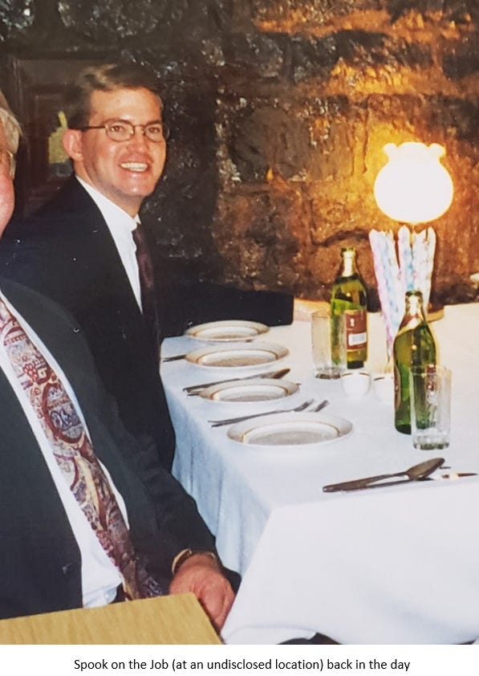](https://substackcdn.com/image/fetch/f_auto,q_auto:good,fl_progressive:steep/https%3A%2F%2Fsubstack-post-media.s3.amazonaws.com%2Fpublic%2Fimages%2F2db3228d-220f-4bb8-8088-e7774232e075_597x842.png)](https://substackcdn.com/image/fetch/f_auto,q_auto:good,fl_progressive:steep/https%3A%2F%2Fsubstack-post-media.s3.amazonaws.com%2Fpublic%2Fimages%2F2db3228d-220f-4bb8-8088-e7774232e075_597x842.png" \t "_blank)

**Let’s tackle a very important question that I am certain readers will want to hear you answer. Shortly after Mueller issued his report in 2019, you argued that there was enough circumstantial evidence presented to show that the 2016 Trump Campaign colluded with Russian officials, but not enough to lay the grounds for an espionage trial. You went further by explaining how you convinced that certain information was not shared as it would be too hot to handle and too difficult for the public to process, as it could jeopardize ongoing operations. I, like many of my readers, remain unconvinced that Trump had colluded with Russia. In fact, I view Trump-Russia as the key conspiracy theory of the 21st century, one that was purposely used to sink a presidency. Without re-litigating the entire affair, can you explain why you think that collusion did occur? Or have you changed your mind the years since the Mueller Report was published?**

Collusion is a tricky word. The big mystery, and failing, of the Muller investigation is how that effort assiduously avoided counterintelligence issues, the heart of the affair, focusing instead on narrower possible illegalities. Why that happened, only Bob Mueller knows, and he’s not talking.

[**My theory**](https://observer.com/2019/04/trump-russia-ties-espionage-full-story-mueller-report/) of what transpired between Trump and Russia around 2016, based on years of investigation plus decades of knowledge of how Russian intelligence really works, is this: Trump was approached by the KGB in the mid-1980s – he was on the radar of the Czechoslovak secret police, the [**StB**](https://link.springer.com/chapter/10.1057/9781403905369_2), before that, thanks to his marriage to Ivana the Moravian beauty, but that didn’t go anywhere operationally – which is how his infamous July 1987 trip to the USSR came about. That was surely a KGB recruitment effort. They did this to Western VIPs regularly. The KGB wanted Trump to be their “agent of influence,” to use the proper Chekist term, which isn’t a “spy” in the Western stealing-secrets understanding, but rather an important foreigner who helps Moscow in various ways in exchange for cash or business opportunities.

What the KGB wanted was a new [**Armand Hammer,**](https://www.britannica.com/biography/Armand-Hammer) the [**Occidental Petroleum**](https://www.referenceforbusiness.com/history2/46/Occidental-Petroleum-Corporation.html) mogul who was their agent of influence for most of the 20th century (for the younger set: he was the great-grandfather of[**Armie Hammer**](https://www.vulture.com/article/armie-hammer-allegations-career-timeline.html), the actor better known for his BDSM cannibal hobby). Moscow used Hammer for decades as a propagandist for the Soviet side, giving him business help in exchange. (Sidebar: Hammer’s consigliere and bestie was [**Samuel Pisar**](https://www.politico.com/news/magazine/2021/01/19/samuel-pisar-tony-blinken-secretary-of-state-460155), the stepfather of Secretary of State Antony Blinken.) However, by the mid-1980s, Hammer was old (he died in 1990) and his Kremlin affiliations were broadly understood. Trump looked like a good replacement to the KGB at the time, Don was famous and flamboyant and rich, and he had a good-sized public audience.

There was a catch: Donald Trump is no Armand Hammer. The latter was a legitimately successful businessman with powerful political connections (he bankrolled the political careers of Al Gore and his father, among others), while Trump is an undisciplined narcissist with poor impulse control. Trump isn’t even a real business success: he managed to bankrupt a casino, after all. Because of this, the KGB eventually thought better about recruiting Trump as an agent of influence, plus the Soviet system fell apart around 1990 anyway, unleashing years of chaos inside their intelligence agencies (and everything else in Moscow).

If you know [**Chekist**](https://alphahistory.com/russianrevolution/cheka/) *modus operandi,* Trump was what Russian spies call a “confidential contact,” which falls well short of the Western definition of an intelligence agent (I’ve explained this all in detail [here](https://topsecretumbra.substack.com/p/words-matter-deciphering-donald-trumps)). Some people don’t even know they are one. Seriously, can you image Trump as any kind of spy? He’d crack under pressure in ten seconds. You’d have to search a while to find someone less temperamentally suited to clandestine work than Donald J. Trump.

Thus, Don never got his Trump Tower in Moscow, which is what he wanted all along. That’s a pretty good tell that the secret relationship between Trump and the KGB (and its post-Soviet successor in foreign intelligence, the SVR) was never consummated. But the Kremlin never forgets. This is the “*kompromat*” on Trump that liberals became obsessed with. It’s not about “pee-pee tapes” and such – the Russians probably do have videos of Trump’s sexual antics, but let’s be honest, Don would brag about them and might post them online himself – rather the secret relationship between Trump and the KGB in the 1980s, the details of which would be embarrassing for Trump, even though that clandestine partnership never really panned out.

For years after the Soviet collapse, Trump had business dealings with various shady Russians, i.e. mob types with KGB connections. Don never gave up his dream of Trump Tower Moscow. He kept certain doors open, and he tried to exploit them in 2016, when he miraculously turned out to have a real shot at the White House. Hence Don’s hiring of third-tier guys like ostrich-jacketed [**Paul Manafort**](https://apnews.com/hub/paul-manafort), who really did have some shady links to Russian intelligence, and oddball [**Michael Flynn**](https://en.wikipedia.org/wiki/Michael_Flynn), the former [**Defense Intelligence Agency**](https://www.dia.mil/) (DIA) director who got cozy with Moscow after he retired from the Army (being fired from DIA by President Obama).

Trump’s error was that he misread Kremlin intentions. Vladimir Putin hated Hillary Clinton more than he liked Donald Trump. Putin blamed Hillary for the 2011 Moscow protests, believing she tried to pull off a “color revolution” in Russia as Secretary of State. Russian machinations in 2016 were about punishing Hillary more than boosting Trump. The concept was to damage Hillary, who was expected by Moscow to win the 2016 election. Trump didn’t expect to win either. Remember, Don had no victory speech ready on election night. Trump’s presidential run started as a grand publicity stunt, an effort by Don to shake loose more money from NBC for future seasons of *The Apprentice*, but it managed to put Trump in the White House, an outcome that neither he nor Moscow had in their plans.

The dirty little secret of the 2016 Trump-Russia story is that Trump wanted a closer relationship with Moscow than he actually had, and the resistance there was in the Kremlin. Putin and his entourage viewed candidate Trump as a publicity-hungry buffoon who was pro-Russian but not terribly useful for Moscow. U.S. and Allied SIGINT agencies intercepted senior Kremlin officials talking about Trump, and all I will say is that their commentary was not flattering to Don.

The absence of Trump’s close relationship with Russian intelligence is proved by that strange July 2016 meeting in Manhattan’s Trump Tower between Team Trump, led by Don Jr., and Kremlin representatives, ostensibly to discuss “adoptions.” The real agenda was that Trump wanted dirt on Hillary from Moscow, which wasn’t supplied. The point is you don’t need to fumble around with such meetings if you’re a *bona fide* Russian agent. Trump then would have the top SVR officer in New York on speed-dial.

Moreover, the Kremlin was messing around with Trump, and not just Hillary, in 2016. Russian intelligence had a hand in the notorious [**Steele Dossier**](https://en.wikipedia.org/wiki/Steele_dossier), which was denounced by real experts (such as [**me**](https://observer.com/2017/10/fact-versus-fiction-in-the-steele-dossier-on-donald-trump/)) on Russian spy games as obvious disinformation, designed to remind Trump that Moscow possessed *kompromat* on him. It worked too well and instead became the focus of anti-Trump mania on the Left.

Once Trump entered the White House, he was his usual transgressive self and did stupid things like invite the Russian Ambassador to the Oval Office, which only “proved” to liberals that he was a Kremlin pawn. Trump became so hobbled by that controversy, which, when coupled with Don’s lazy inability to ever figure out how the Executive Branch which he controlled actually worked, meant that Moscow wound up disappointed in Trump, who over four years never managed to shift U.S. policy in any pro-Kremlin direction worth mentioning. Indeed, in policy terms, Trump’s administration was harsher towards Moscow than Obama was.

To sum up: both sides have it wrong. The Left’s insistence that Trump “was installed to destroy us” sounds plausible to “Resistance” wine moms but is complete fantasy. Russian intelligence ran disinformation and propaganda operations against the U.S. 2016 election, but more to smear Hillary than boost Trump. Their impact on the election was slight in any event. However, the Right’s insistence that the “Russia hoax” as Trump calls it was a figment of the liberal imagination isn’t true either. Trump’s conduct in 2016 can’t be called espionage, but Don would have colluded more closely with Moscow if he’d been allowed to. The Kremlin didn’t want that.

**Whether by design or through opportunism, "Trump-Russia" can be argued as a psyop to lay the groundwork to manufacture consent for a more aggressive approach from the USA toward Russia. Back in 2012, Mitt Romney accused Obama of being "soft on Russia". With "Trump-Russia", the other side of the aisle is now onside with at least squeezing Putin (and with some others adamant about effecting regime change in Moscow). To not have a belligerent stance toward Moscow is to be on par with Donald Trump, and therefore, in the eyes of many, a traitor to America. Where you and I will agree is that Russia has committed aggression against Ukraine, but you and I will disagree with respect to American encroachment via NATO in Russia's "near abroad". I have zero doubt in my mind that you would not be willing to tolerate a Beijing client state in Mexico City, and with good reason. What the Russians have done is committed a natural reaction, akin to your country and how it reacted to the presence of nuclear missiles on Cuban soil in 1962. Your country successfully cornered Russia in Ukraine, forcing Putin to choose between a NATO-ized Ukrainian state (and all the existential dangers that would result from it), and invading, which resulted in the complete split of Russia from Europe economically and politically. Your country won on the first day of this war, everything since then has been gravy.**

The myth has taken hold in Russia-friendly circles that NATO expansion is the whole problem here. This simply isn’t true. Moscow didn’t seriously object to the former Warsaw Pact states joining NATO, as they started to in 1999. Even the Baltic States entering the Alliance wasn’t a major redline for Moscow, contrary to Kremlin rhetoric. Ukraine was always different, for obvious historical reasons. The root problem, just as in the former Yugoslavia, is that Communist internal boundaries of the USSR, drawn up by Bolsheviks for *divide et impera* reasons without consideration for ethnic realities, suddenly became international borders in 1991.

To condense recent history, it’s worth mentioning that in his early years in the Kremlin, [**Putin discussed Russia possibly joining NATO**](https://www.theguardian.com/world/2021/nov/04/ex-nato-head-says-putin-wanted-to-join-alliance-early-on-in-his-rule)! Things only went sour starting around 2004, when Putin felt that he had helped the Americans with their War on Terror and didn’t get much in return. The Kremlin expected to be treated as an equal great power, but Dubya and friends, distracted by their self-created Middle East disasters, didn’t get it. From that point forward, NATO expansion grew into a major irritant for Moscow. Then came the [**NATO summit in Bucharest in April 2008**](https://www.washingtonpost.com/world/2023/07/10/bucharest-2008-nato-summit-history-vilnius-putin-georgia-ukraine-membership/), where the alliance endorsed admitting Ukraine and Georgia at an unspecified date in the future. Washington wanted Ukraine and Georgia in NATO, while some European members were decidedly skeptical. The compromise was that Kyiv and Tbilisi got no admission date; and even more importantly, they didn’t get a [**Membership Action Plan**](https://www.rferl.org/a/1079718.html) (MAP) from the alliance, which is an applicant country’s bureaucratic roadmap to joining NATO (for example, Croatia got its MAP in 2002, then a formal invitation to join NATO in 2008, followed by official membership in 2009).

What NATO offered Ukraine and Georgia in Bucharest was a nebulous promise that they would enter the alliance sometime between next week and the end of geologic time. It was at root a sham, which did nothing to improve those countries’ security, but it was sufficient to enrage the Kremlin. Putin acted fast. Four months after the Bucharest summit, Russia executed a [**quick attack**](https://www.wilsoncenter.org/event/the-russia-georgia-conflict-what-happened-and-future-implications-for-us-foreign-policy) on Georgia, which taught Tbilisi a harsh lesson and changed the “facts on the ground.” In less than a week, the Russian military cemented its control over one-fifth of Georgia’s territory.

The plain truth is that NATO will never admit any country which doesn’t control every inch of its sovereign territory. Otherwise, you’re letting in a member that’s in “pre-[**Article V**](https://www.nato.int/cps/en/natohq/topics_110496.htm)” status. That’s not happening. Over the last 15 years, remarkably little has changed. Ukraine and Georgia are both sort-of candidates for NATO admission, but not really.

In Ukraine’s case, dangling this insincere offer of NATO membership served only to drive Putin and his retinue into paroxysms of rage, while adding nothing to Ukrainian defense and security. Maintaining the “You’ll be in NATO … someday!” fiction after 2014, when Putin smash-and-grabbed Crimea and then occupied part of the Donbas, was a cruel joke by the West at Kyiv’s expense. A core strategic principle is the Value of the Object: bluntly, how much do you care about something? There is no universe where NATO cares more about Ukraine, and who controls it, than Russia does. Look at a map and learn Wikipedia-level history, folks. Apparently, that was too much to ask of the U.S. foreign policy elite.

German Chancellor Otto von Bismarck, who had several good one-liners, is supposed to have said that “God has a special providence for drunks, fools, and the United States of America”. *Se non è vero, è ben trovato*, as the Italians put it.

[[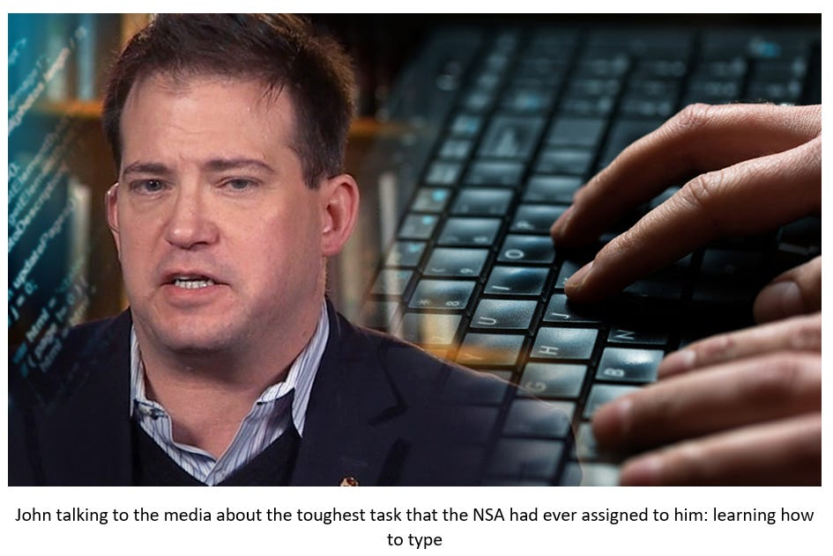](https://substackcdn.com/image/fetch/f_auto,q_auto:good,fl_progressive:steep/https%3A%2F%2Fsubstack-post-media.s3.amazonaws.com%2Fpublic%2Fimages%2F84b6b523-a2cd-4305-ac1a-a5608defaea3_945x632.png)](https://substackcdn.com/image/fetch/f_auto,q_auto:good,fl_progressive:steep/https%3A%2F%2Fsubstack-post-media.s3.amazonaws.com%2Fpublic%2Fimages%2F84b6b523-a2cd-4305-ac1a-a5608defaea3_945x632.png" \t "_blank)

**No one has gotten this conflict right and predictions have repeatedly fallen flat. I didn't believe that the Russians would invade, nor did I believe that they would go in with such a light touch after doing so. Military figures like former US General (and CIA Director)**[**David Petraeus**](https://www.centcom.mil/ABOUT-US/LEADERSHIP/Bio-Article-View/Article/904777/david-howell-petraeus/)**have predicted a**[**great success**](https://www.pravda.com.ua/eng/news/2023/06/4/7405207/)**for the Ukrainians in their current stalling counter-offensive. As I am conducting this interview, I am going to put you on the spot and ask you to forecast what will happen in Ukraine between now and November of 2024 in the military, geo-strategic, and diplomatic realms. Lastly, can you share with us your thoughts on the Prigozhin Affair, with specific mention of the intel chatter surrounding it?**

I see no reason for the Ukraine War to end anytime soon. Both sides have enormous sunk costs in lives and treasure. This could become the Iran-Iraq War, but in Europe. I expect no significant changes between now and the U.S. election next year. Both sides appear strong enough to keep fighting, but not strong enough to execute strategic wins.

Moreover, the West wants Ukraine to keep fighting, to wear down Russia and hopefully weaken the Putin regime. NATO has encouraged Zelenskiy to embrace war aims (including Moscow’s withdrawal to pre-2014 borders), that no Russian government can accept, politically speaking. Putin’s view of Ukraine, that it’s not really a country, and that Crimea is rightfully Moscow’s, is taken as bizarre in the West, but it’s a view held by most Russians. When Putin seized Crimea with GRU’s [**Little Green Men**](https://mwi.westpoint.edu/from-little-green-men-to-little-blue-helmets-imagining-the-future-of-russian-aggression-and-what-to-do-about-it/) in 2014, I heard from lots of Russian friends living in the West, all of whom hated Putin. Without exception, they admitted that Putin had finally done something great.

The tragedy here is that by April 2022 (when both sides realized they were trapped in a nightmarish conflict that was staggeringly costly), there were discreet diplomatic off-ramps. This would have involved a ceasefire and Russian withdrawal to pre-2022 (but post-2014) boundaries, with eventual UN-brokered plebiscites on the future of the Donbas and Crimea. In exchange, Ukraine would be allowed to join the EU as soon as feasible, while NATO membership would be off the table for a decade (with the issue to be reopened every ten years via multilateral diplomacy). That could have been achieved. It was NATO who didn’t want that deal. Hence the war continued, bringing hundreds of thousands more dead and wounded Ukrainians and Russians.

Now, both sides are stuck in a terribly costly war that nobody can get out of. Per the cliché: wars are easy to start and hard to stop. The failure of Ukraine’s vaunted summer offensive to achieve anything of strategic value while burning through an awful lot of NATO-gifted weapons and munitions, means that the war will quiet down for a few months before going hot again in the spring. The conflict is now attritional, resembling WW1 more than anything else. Given Russia’s much bigger population and industrial capacity, it’s difficult to see how Ukraine can win the war, even with NATO’s prodigious support. Plus, Zelenskiy’s Churchill-but-shorter act has gotten stale, as witnessed by the mixed response from Congress he got on his recent visit to Washington. His choosing a [**needless fight over grain imports**](https://www.theguardian.com/world/2023/sep/21/poland-stop-ukraine-weapons-supply-grain-exports-dispute) with Poland, Ukraine’s biggest partner in the war, is another sign that the wheels are starting to come loose in Kyiv.

Even in the best case scenario where there’s a sudden regime change in Moscow and Putin dies or is removed from the Kremlin, what will be left of Ukraine? Large swathes of the country have been ravaged by war. We have no idea how many Ukrainians have been killed or maimed for life, and the population of the country is dwindling fast. When the USSR was dissolved in 1991, Ukraine had over 50 million people. This number fell to 45 million by 2013 thanks to its terrible demographics (Russia’s are only slightly better). The last decade of war has seen millions of Ukrainians fleeing abroad. Since February 2022, over 15 million Ukrainians have fled to the West via Poland alone. How many of them will ever go home? Recently, the Jamestown Foundation, which was created by the CIA in the 1980s and is ebulliently pro-Kyiv, [**casually admitted**](https://jamestown.org/program/ukraines-personnel-needs-reaching-a-critical-threshold/) that Ukraine’s population has dwindled to 20 million people. If Putin’s aim is to wreck Ukraine, depopulate it, and turn whatever’s left of it as a Russian satellite…..well….that can be achieved.

It’s also important to mention that if the Putin regime falls, what’s likely to replace it is a more nationalist regime, not any pro-Western liberal clique that takes its lead from *The Economist*. Most of the “antiwar” sentiment in Russia that the West plays up isn’t opposed to the war; it’s nationalist anger at Putin for waging the war so diffidently and incompetently. They want to win.

Which brings us to Putin’s recently deceased chef-turned-warlord, Yevgeniy Prigozhin, who tried to use his mercs from the Wagner Group (who bore the brunt of the awful [**Bakhmut meatgrinder**](https://www.dw.com/en/ukraine-the-battle-for-bakhmut/a-65214800)), to overthrow the regime. Prigozhin and his supporters were angry at Putin and the General Staff for making a hash of the war, one which they fully endorsed. They resemble the German [***Freikorps***](https://www.britannica.com/topic/Freikorps) circa 1919, not peace activists.

What exactly happened with Prigozhin and his June pseudo-coup is difficult to assess. The notion of Wagner marching on Moscow with a brigade worth of mercenaries isn’t exactly sound planning. Plus it’s Russia: so the issue of provocation, the ubiquitous *provokatsiya*, arises. There’s no way that the FSB, the powerful domestic security service (which monitors the military), had no inkling of Prigozhin’s plans. I suspect what happened is that Prigozhin was sincere, if not reality-based in his plotting, yet a degree of the “coup” was stage-managed by the FSB to assess the loyalty of generals and others to the Kremlin. In other words, it was like [**what happened in Turkey in 2016**](https://www.france24.com/en/europe/20210715-turkey-marks-fifth-anniversary-of-failed-coup-against-erdogan), when there really was a coup attempt against Erdoğan, but where he played it up as bigger than it actually was, to allow the [**AKP**](https://www.arabnews.jp/en/45thanniversary/article_20906/) to solidify control over the military and security services, while purging any lingering pockets of opposition. It was real and fake at the same time.

**While this war drags on, consensus is beginning to build that China also stands to be a big winner of the conflict as the USA continues to split its focus between its two main rivals, Moscow and Beijing. This war has allowed China some breathing room after it was being squeezed by the USA on three fronts just before COVID-19 hit: 1. the propaganda campaign about "genocide" in Xinjiang, 2. "Pro-Democracy" protests in Hong Kong, and 3. trade squeeze. The COVID-19 Epidemic slightly relaxed this grip. Your focus has been on the domestic front with respect to the Chinese, specifically their current intelligence operations. It is no secret as to just how effective their industrial espionage efforts have been. You have sounded the alarm about**[**China's infiltration of the US Navy**](https://www.washingtonexaminer.com/restoring-america/courage-strength-optimism/chinas-infiltration-of-the-us-navy-is-a-general-quarters-alert-for-the-nation)**. You have also raised the question as to whether President Joe Biden is himself a "**[**Chinese agent of influence**](https://www.washingtonexaminer.com/restoring-america/patriotism-unity/joe-biden-looks-like-a-chinese-agent-of-influence)**". The USA has chosen to take on both Russia and China simultaneously, albeit in different ways. Has your country’s foreign policy establishment bitten off more than it can chew?**

The current debate in the Pentagon and the Intelligence Community isn’t about ***if*** Xi and the People’s Liberation Army will make a move on Taiwan, but ***when***. How much time can Washington buy with enhanced deterrence – years or more like months? Senior U.S. intelligence officials have been [**banging the drum**](https://topsecretumbra.substack.com/p/top-us-spies-warn-war-with-china)**,** but the Biden administration is delusional. While I don’t think any cross-strait invasion by the PLA is imminent, it’s obvious when you look at Chinese military exercises and deployments that they are practicing for a blockade of Taiwan, perhaps soon.

The U.S. military isn’t in great shape. Two decades of losing wars of choice took their toll. The humiliating [**retreat from Kabul**](https://www.theguardian.com/us-news/2023/jun/30/us-afghanistan-war-military-pullout-report-biden-trump) in August 2021 signaled the end of American Hegemony and everybody but the Beltway crowd gets this. Recruiting is in the toilet, not helped by Woke agitprop coming from senior Pentagon leaders. Ammunition stocks are low, thanks in part to the Ukraine War. The U.S. military wasted a generation expensively punching down against goat herders. They haven’t fought against a peer adversary in a very long time. American airpower hasn’t had to fight for air supremacy since 1943. If the balloon goes up with China, the Pentagon is in for a bunch of unpleasant and costly surprises.

That said, Beijing isn’t ready to go to the dance either. The PLA hasn’t fought anybody since 1979, when Vietnam handed them their ass in a humiliating fashion. Although Chinese military spending is impressive, and they do have lots of neat technology (much of it stolen from the West), the PLA’s navy has never fought anybody. Can they really pull off combined amphibious operations, famously the most complex of military undertakings? If I were Comrade Xi, I’d have lots of questions. Above all other questions: is PLA leadership playing it straight? Are their strategic assessments grounded in military reality, or are they just what the Party wants to hear? Xi gets one shot at reuniting Taiwan by force. If he winds up like Putin in Ukraine (with a stalemated debacle of choice on his hands and a bloody humiliation before the world), that could easily mean the demise of the Chinese Communist Party, and Xi himself.

**I for one have repeatedly argued against the idea that the USA is collapsing or significantly declining, even if signs of decline are quite abundant and visible. I am not aware of your take on this debate. Are you of the opinion that decline is an actual fact at present? If so, is this decline visible in the NatSec community too? America, in many ways, has become a bully on the global stage (left wingers will argue that this has always been the case). Where the Chinese show up and build new infrastructure, the Americans arrive with lectures and demand that the locals change their cultures overnight to reflect constantly-shifting US mores. You yourself have written that the**[**pride flag is now the flag of US Empire**](https://www.washingtonexaminer.com/restoring-america/patriotism-unity/the-pride-flag-is-now-the-flag-of-american-empire)**.**

I think Obama’s two terms in the Oval Office, particularly his second, brought major changes to American life, both at home and abroad, and only recently has that become obvious. I don’t envision a U.S. collapse anytime soon, nothing that dramatic or interesting. No Civil War 2.0, not even Max Mad: America. However, if 2024 is a Biden vs. Trump rematch (which seems rather likely at present), no matter who wins, we’re going to have a large chunk of Americans who don’t see the outcome as legitimate or legal, and that’s certainly no recipe for stability.

That said, my concerns about American life focus more on Mike Judge’s 2006 movie [***Idiocracy***](https://www.youtube.com/watch?v=6lai9QhBibk), because it was so hilariously prescient. At this point, over three-quarters of American 18-year-olds can’t join the U.S. Military because they’re stupid, addicted, fat, criminal, or crazy. That’s a withering indictment of this country, but I intend to enjoy the decline as best I can, poolside.

The [**deterioration of the U.S. NatSec community**](https://www.washingtonexaminer.com/opinion/another-counterintelligence-breach-at-the-nsa) cannot be separated from this. This year, [**Congress ordered**](https://newjerseymonitor.com/2023/03/10/congress-unanimously-votes-to-require-declassified-information-on-covid-19-origins/) the Director of National Intelligence to provide declassified answers regarding the origins of Covid-19 and…the DNI just didn’t do it. IC leadership flagrantly ignored the law and the MSM said nothing. The increasing involvement of top military and intelligence officials in partisan politics ought to disturb everyone. Politicization is cancerous for NatSec organizations, which are supposed to defend the whole country. This isn’t rocket science, but it seems unstoppable now.

The public embrace of LGBT everything in U.S. foreign relations is a perfect symbol of this navel-gazing strangeness. The postmodern West, what I call WEIRDistan (from [**Western, Educated, Industrialized, Rich and Democratic**](https://news.harvard.edu/gazette/story/2020/09/joseph-henrich-explores-weird-societies/)**)**, simply can’t grasp how anyone else approaches reality. The idea that current U.S. elite opinions on sex and gender – which, I remind everyone reading this, have only taken hold over the past decade – are the only acceptable global standard is bizarre and unhelpful to achieving U.S. foreign policy goals, but the Woke just can’t see it. They’re as blinded by their mythology as 19th century Protestant missionaries who headed out into central Africa to “save” the natives were. Not long before the U.S. Embassy in Kabul fell to the Taliban in 2021, they [**tweeted out**](https://twitter.com/USEmbassyKabul/status/1400060130243362816) the wonders of LGBT including pictures of the Pride Flag over the Embassy. It was perfect, really.

**Public trust in governing institutions and media has collapsed in your country, and with good reason. Whether it be the failure to find WMDs in Iraq, the "Trump-Russia" debacle where almost every day a new "bombshell" was reported only for it to be proven a dud shortly thereafter, the Epstein Affair, Hunter Biden's laptop and how intel colluded with social media to suppress the story, and the bankruptcy of health expertise during COVID-19......no one knows who in authority is to be trusted anymore. What explains this crisis in trust? For example, I, like you, consider the Epstein Affair to be much more an intel story than one about prostitution and sexual abuse, but that angle of approach has been successfully closed off. Another example: just two weeks ago, an anonymous whistleblower has alleged that the**[**CIA bribed its own COVID-19 origin team**](https://www.science.org/content/article/cia-bribed-its-own-covid-19-origin-team-reject-lab-leak-theory-anonymous-whistleblower)**to reject the lab leak theory.**

We can’t get away from the difficult reality that across the West, public confidence in our institutions has gone off of a cliff over the last decade. Why shouldn’t it? Our elites look like a bunch of incestuously corrupt thieves and sex criminals. The [**Epstein Affair**](https://observer.com/2019/07/jeffrey-epstein-spy-intelligence-work/) has been made to go away since its obvious implications – Western elites were being systematically compromised by a creepy guy who knew all the right VIPs, plus who had access to battalions of teenage sex slaves…..a guy who had to have [**a powerful secret organization**](https://topsecretumbra.substack.com/p/the-epstein-scandal-and-intelligence) behind him – were just too much for the media to process. Hence the focus on Epstein’s lurid personal life rather than asking what was really going on there.

The suppression of the COVID-19 origins story, apparently with CIA connivance, is another one that the public won’t forget about anytime soon. I have no informed opinion on where the pandemic came from, other than: Wuhan. I’m not a virologist. But I know that Commies always lie. Even when they don’t have to. Moreover, every single expert I know who has an informed opinion (I’m referring to serious scientists), privately has told me from the beginning of the pandemic that COVID-19 was made in a Chinese lab. Most of these folks are card-carrying liberals, but they know the truth, and that it cannot be stated openly. The fact that U.S. Government money was paying for risky gain-of-function research in Wuhan, even after U.S. diplomats had reported safety problems in that lab, is the worst part of all. But it seems there will be no consequences. As has become the new normal. Consequences are for little people, and the little people have noticed.

**All of these cases have created the space for conspiracy theory culture to blossom in the USA and beyond. The fact is that people conspire all the time. Conspiracy theories thrive where public trust is absent. How can authorities and elites restore public confidence in such a polarized society where almost every issue becomes an existential one, and the media happily plays the role of arsonist?**

It's a huge problem and I don’t see it getting better. The public is profoundly polarized, half the country hates the other half – optimistically, 45 percent hates the other 45 percent, with 10 percent just trying to hide from it all – thus every political fight becomes a *va banque* round. Opinion-makers have so stigmatized “conspiracy theories” that they push any remotely controversial discussion to the fringes, where the elites want it. The pattern is very consistent:

The media pronounces that a given subject is a “conspiracy theory” and must not be discussed. Therefore, only the fringes discuss it. That fact is cited by the media as proof that “only crazy people” care about the topic, which proves why they banned talking about it in the first place.

The [**Hunter Biden laptop coverup saga**](https://nypost.com/2020/12/10/greenwald-posts-hunter-biden-reports-suppressed-by-media/) was too much, too blatant, and it didn’t work for very long, but this *modus operandi* generally works well at keeping many topics off-bounds for polite discussion. When it fails, the trick is to then make up something ridiculous for the rubes in order to render any reality-based discussion out of bounds. Take QAnon, which isn’t really a conspiracy theory so much as a parody of one. Alas, millions of [**Boomers with computers**](https://www.joeydevilla.com/wp-content/uploads/2020/08/boomer-with-a-computer.jpg)weren’t in on the joke. If you have any notion of how the “Deep State” functions in earthly reality, QAnon was transparently crazy, a low-rent fake….but millions of Americans lapped it up. That was awfully convenient when the Epstein Affair broke – here was an actual elite pedophile ring involving presidents, princes, and many billionaires, run by shadowy evil forces – and the QAnon bullshit had pre-tainted any discussion of such realities with the mark of online crazy.

What we don’t want to become is Italy, where everything is viewed through a profoundly conspiratorial lens. It’s so ubiquitous they have a word for it, [***dietrologia (“behindology”****)*](https://topsecretumbra.substack.com/p/when-behindology-gets-out-of-hand). In this formulation, literally everything is a conspiracy. Facts really don’t matter. It’s a novel way to run a country. I’m advocating for some healthy middle ground. On the other hand, if we can get Italian food, wine, and *dolce vita*, then *dietrologia* might be worth it.

I’ve toyed with setting up a website, perhaps a YouTube channel, called *The Rational Conspiracist*, for informed discussion of real-world conspiracies and how they operate, based on actual intelligence experience. I remind you that the Russian word for espionage tradecraft is *konspiratsiya*. It might be fun, who knows?

**Let’s switch gears for a minute and move to a subject that interests both you and I immensely: the Balkans. In July of 1994, I was visiting Croatia and I was on my way from Split on the coast to my birthplace, the town of Livno, just over the border in Bosnia and Herzegovina. As we passed near the Dalmatian city of Sinj, we were informed by local police that we could not take the road any further, as it was reserved for military purposes. My uncle managed to get us on that road several hours later. Upon arriving in my village, I quickly learned that the reason that road was shut down for several hours every day was so that the Croatian Military (HV) could use it to move weapons into my county in preparation for offensive operations against the Bosnian Serbs later that year. I got to see some of the gear over the course of the next week, including a tank that was camouflaged roughly 50 feet from my house. It wasn't until later that I learned that these new weapons and assets came from Iran,**[**courtesy of a deal brokered between Washington DC and Tehran**](https://www.latimes.com/archives/la-xpm-1996-04-05-mn-55275-story.html)**, whereby arms would be sent to the island of Krk in the Northern Adriatic for unloading. Half of the weapons that arrived there were given to the HV, and half of what remained would be given to Croatian forces (HVO) in Bosnia-Herzegovina once it crossed the border. What was left over would be allotted to the ABiH (Army of Bosnia-Herzegovina). Very similar to**[**Iran-Contra**](https://en.wikipedia.org/wiki/Iran%E2%80%93Contra_affair)**, this time it was a Democrat-occupied White House that worked with the Iranians, long a target of your country for regime change.**

**You have had some experience in the Balkans and have**[**written quite a lot on this subject**](https://www.amazon.co.uk/gp/product/0760330034/ref=dbs_a_def_rwt_bibl_vppi_i3)**. The war in Bosnia in particular saw not just Iranian agents involved on the ground (Hezbollah was aiding the ABiH militarily), but also Salafist radicals,**[**two of whom**](https://www.bbc.com/news/world-europe-33345618)**would go on to attack the USA on 9/11. Salafis and Iran on the same side in a conflict shows that war makes for strange bedfellows. The Mujahideen who arrived in Bosnia were a very vicious sort, responsible for all sorts of war crimes. Can you shed some light on the activities of the Mujahideen? Who sponsored their arrival? And what the fallout was beyond Bosnia? Can you also explain how the USA worked with Iran in Bosnia without it erupting into a national scandal back home?**

Your hailing from Livno explains … everything. Just kidding. But not really.

The Bosnian War of 1992-1995 witnessed several problematic narratives for Western elites. The actual war bore only passing resemblance to the conflict as reported by Western media nonstop for years, during that fleeting moment after the arrival of 24/7 cable news programs but before the appearance of Internet fact-checking. I exposed all this in my 2007 book, [***Unholy Terror***](https://www.amazon.com/Unholy-Terror-Bosnia-Al-Qaida-Global/dp/B0044KMWPI), which the MSM ignored because it was stuff that they worked hard at suppressing the decade before. Here I was, an Intelligence Community whistleblower, exposing the dirty underside of the Bosnian War, which included considerable American contribution and connivance, and, well, that wasn’t something that the media wanted to hear. Hey, I was only the technical director of NSA’s Balkans Division, what did I know?

What got omitted from MSM coverage included ugly and important stories. Al-Qa’ida turned into a global threat thanks to their jihad waged in Bosnia, thus paving the road to 9/11, and part of that growth was fueled by Iranian intelligence. Saudi money and Iranian logistics plus training enabled the Bosnian jihad, especially the foreign Mujahideen who committed ample war crimes against Serbs and Croats (which the Western media ignored). Bosnia's muj, who came from all over the Islamic world, did all the nasty stuff they do everywhere – torture, decapitations, murders of non-combatants….the typical hideous scenes we’ve come to expect from the black-clad guys with swords – but the MSM showed no interest in any of it. Contrary to *bien-pensant* myth, Sunni and Shia radicals work together just fine when they share a common enemy. This story was well known in Western intelligence circles in the 1990s, but the MSM suppressed it all.

Even more embarrassing for the Clinton White House was the very dodgy secret operation run out of the National Security Council to get Iranian and other Islamic weapons to Bosnia, in defiance of the UN arms embargo. Croatia played along because they took a healthy cut. It was an exact parallel to the Iran-Contra scandal that nearly took down the Reagan administration in its second term: a deniable, (because illegal), arms ring partnered with our enemy Iran run out of the NSC (not the Intelligence Community). That brouhaha was reported on *ad nauseum* by the MSM and resulted in high-profile Congressional investigations and even a [**Special Counsel**](https://en.wikipedia.org/wiki/Lawrence_Walsh) that long outlasted the Reagan administration, and don’t forget the prosecutions of senior officials. Clinton’s remarkably similar scandal – nearly a carbon copy of Iran-Contra less than a decade later – got very little media attention, a [**perfunctory tepid Congressional investigation**](https://www.govinfo.gov/content/pkg/CRPT-105hrpt804/html/CRPT-105hrpt804.htm), no major inquiry, and no prosecutions. It’s like it never happened. The power of the MSM to suppress stories they don’t like is nothing new.

[[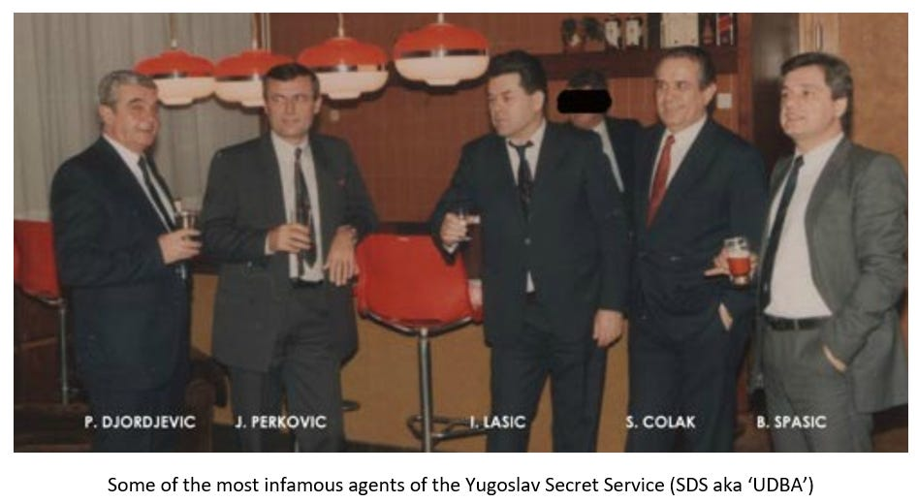](https://substackcdn.com/image/fetch/f_auto,q_auto:good,fl_progressive:steep/https%3A%2F%2Fsubstack-post-media.s3.amazonaws.com%2Fpublic%2Fimages%2F87cdf8d9-fde3-401e-92f8-2a5de0c9cf1c_947x519.png)](https://substackcdn.com/image/fetch/f_auto,q_auto:good,fl_progressive:steep/https%3A%2F%2Fsubstack-post-media.s3.amazonaws.com%2Fpublic%2Fimages%2F87cdf8d9-fde3-401e-92f8-2a5de0c9cf1c_947x519.png" \t "_blank)

**Staying in the Balkans, you have long had a fascination with**[**UDBA**](https://en.wikipedia.org/wiki/State_Security_Administration_(Yugoslavia))**, the secret service of Communist Yugoslavia. You have claimed that they were more effective than the Mossad in eliminating targets. In Western Europe alone, they managed to liquidate almost 70 exiled regime opponents during the 1960s and 70s, mainly Croatian nationalists, and some Albanian nationalists from Kosovo as well. Just how good were they and what made them so dangerous and effective?**

The Yugoslav secret police, which went by several names between 1945 and 1991 (it was UDBA for a long time, the handle stuck), was highly proficient and very nasty. There is no doubt that the Tito regime, for all its shortcomings, excelled at secret intel stuff. [**Marshal Tito**](https://www.britannica.com/biography/Josip-Broz-Tito) himself, [**whoever he really was**](https://20committee.wordpress.com/2012/07/10/was-tito-really-tito/), had been a Soviet secret agent with 33 cover names to his credit. When the shit hit the fan in 1948 and Stalin kicked Yugoslavia out of the Commie Club, the Kremlin went all in on covert efforts to collapse the regime and assassinate Tito. They failed. UDBA was the only spy service to decisively defeat the KGB at their own game.

UDBA was better at assassinating people abroad, what the Russians call “wetwork” (from bloody hands), than the KGB. Contrary to myth, the Kremlin was somewhat timid for most of the Cold War about assassinating enemies in the West – in stark contrast with Vladimir “Honey Badger” Putin, the Chekist-in-Chief, who uses his spy agencies to radiate and shoot people all over the place. The last KGB assassination in the West was [**Stepan Bandera**](https://www.dw.com/en/stepan-bandera-ukrainian-hero-or-nazi-collaborator/a-61842720), the Ukrainian nationalist (a terrorist to the Kremlin) in Munich in 1959. It wasn’t worth the political heat for Moscow, so they got out of the wetwork game. We just passed the 45th anniversary of the assassination of the Bulgarian dissident [**Georgi Markov**](https://www.dw.com/en/stepan-bandera-ukrainian-hero-or-nazi-collaborator/a-61842720)in London, victim of the infamous [**umbrella murder**](https://topsecretumbra.substack.com/p/remembering-the-kgbs-murderous-history). What’s important here is the KGB supplied the Bulgarian secret police, the DS, with the new killing device at Sofia’s request, but KGB leadership ordered their own officers to be nowhere near the actual assassination. Too risky for Moscow.

UDBA was smarter and sneakier about all this. By the mid-1960s, Belgrade had a serious problem with what they called the “enemy emigration.” This was the downside to letting millions of Yugoslavs move to the West for work: they were free to pursue anti-Communist activism, including some terrorism, mostly of an amateurish sort. Tito didn’t play. He ordered UDBA to crush the radical emigres with what they called “black actions” (*crne akcije*).

In effect, UDBA outsourced wetwork to the mafia. UDBA was already in contact with Yugoslav organized crime. They worked together on the Balkan Route for drugs, including heroin (Commie secret police in neighboring Albania and Bulgaria did the same). So, they cut the mafiosi a deal: You kill people abroad for us, in exchange we give you multiple passports, you can commit other crimes with these clean IDs, but if you get caught, we don’t know you.

It was ingenious, yet insidious. From the mid-1960s to 1990 (the last UDBA hit abroad was the Kosovar Albanian activist [**Enver Hadri**](https://en.wikipedia.org/wiki/Enver_Hadri), gunned down in Brussels) this secret program murdered or abducted/kidnapped something like one hundred Yugoslavs in the West. Most victims, more than two-thirds, were Croats, but Albanians and Serbs who opposed the Communist regime were murdered too. A lot of these assassinations happened in West Germany, since that’s where so many Yugoslav *Gastarbeiter* lived, but we know of UDBA assassinations on five different continents. There were a dozen UDBA hits in the USA. Some of the victims were [kids](https://20committee.wordpress.com/2012/09/01/who-killed-little-ivanka/). Really disgusting stuff.

When UDBA assassins were caught, which on occasion they were, they were career criminals and the hit looked like some gangster beef, not a state-sanctioned murder. The trail seldom led back to Belgrade. Plus, Balkan émigré politics were impenetrable to Western cops, who had minimal understanding of Yugoslav politics and ethnic animosities. As a result, UDBA got away with a truly global killing spree without precedent anywhere.

Western countries were complicit here too. U.S. intelligence, among several Western spy agencies, knew what UDBA was up to, at least generally, but seldom was action taken. On rare occasions, a Yugoslav “diplomat” (an undercover UDBA officer) would get expelled from a Western country after a particularly nasty hit went down. But the painful truth is that Tito and his regime were strategically useful to NATO during the Cold War, so the West pretended that Belgrade’s global murder spree wasn’t happening.

Neither have Yugoslav successor states been exactly eager to seek justice. Croatia, after hard-won independence in 1991, broadly decided to let the difficult past pass away. This is because Croatia’s then-President [**Franjo Tudjman**](https://www.predsjednik.hr/en/bivsi-predsjednici/franjo-tudman/), a clever fellow and former Yugoslav Army General, understood that he needed the support of the Croatian part of UDBA (the SDS, to be pedantic) to escape from Yugoslavia. Spooks knew the collapse of Yugoslavia was imminent by the late 1980s. As a result, Tudjman co-opted them to his cause. The *quid pro quo* was that UDBA veterans wouldn’t get prosecuted for killing dozens of fellow Croats abroad during the Cold War. Hence, [**Josip Perković**](https://en.wikipedia.org/wiki/Josip_Perkovi%C4%87), who headed the Croatian UDBA’s wetwork department in the 1980s, and then sided with Tudjman in the 1990s, is currently sitting in a prison cell – a German cell, not a Croatian one – due to receiving a life sentence for the [**brutal murder of a Croatian émigré**](https://en.wikipedia.org/wiki/Stjepan_%C4%90urekovi%C4%87) in Munich in 1983.

The bigger impact here is that UDBA’s outsourcing assassinations to mafiosi, many of them Serbs, gave the country a bunch of unpleasant, state-connected guys who didn’t mind killing. When Yugoslavia fell apart, they found their moment, leading militias and armed gangs, killing and stealing for fun and profit. It’s not a coincidence that the notorious [**Arkan**](https://www.youtube.com/watch?v=nXaQuWTYKCY), formally Željko Ražnatović, who ran a reign of terror in Croatia and Bosnia 30 years ago, got his start with UDBA. He was one of many.

[[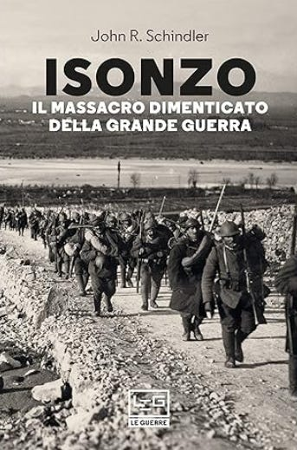](https://substackcdn.com/image/fetch/f_auto,q_auto:good,fl_progressive:steep/https%3A%2F%2Fsubstack-post-media.s3.amazonaws.com%2Fpublic%2Fimages%2Fd7040a23-749c-4944-be4f-d8bb083ff5d7_343x519.png)](https://substackcdn.com/image/fetch/f_auto,q_auto:good,fl_progressive:steep/https%3A%2F%2Fsubstack-post-media.s3.amazonaws.com%2Fpublic%2Fimages%2Fd7040a23-749c-4944-be4f-d8bb083ff5d7_343x519.png" \t "_blank)

**It would be remiss of me to not bring up the subject of WW1 and especially the Austro-Hungarian Empire, which you feel some attachment to. You have written a**[**great book on the Battle of the Isonzo**](https://www.amazon.co.uk/gp/product/0275972046/ref=dbs_a_def_rwt_bibl_vppi_i2)**which took place in Northeastern Italy over the course of two years (1915-17). A horrendous slaughter, it is practically unknown in the West, where the trench warfare of France and Belgium dominates the imagery of that war in our minds. What made this battle so significant and who were some of the standout characters from both the Italian and Austro-Hungarian sides?**

I’ll talk about the Isonzo campaign all day long. A dozen big battles, some of the most savage fighting in the history of warfare with well past a million casualties, and few in the West have heard of it. Imagine [**Verdun**](https://www.iwm.org.uk/history/what-was-the-battle-of-verdun), but bigger, in the mountains, going on for two-and-a-half years. The Isonzo fighting played a major role in the coming of Fascism to Italy – I won’t spoil it: read [**my book**](https://www.amazon.com/Isonzo-Forgotten-Sacrifice-Great-War/dp/0275972046)– and Mussolini himself fought there and was wounded in action on the Isonzo.

It's a wild cast of characters. One of my favorites is [**Gabriele d’Annunzio**](https://niccolo.substack.com/p/gabriele-dannunzio-ecce-homo), the famous Italian artist/nut who was then in his 50s and almost a senior citizen, and who took time away from his busy schedule of writing books and banging hot chicks half his age (as artists do), to show up on the Isonzo front and exhort a leery battalion into a suicide mission (charging Austrian positions), which turned into a slaughter at the hands of enemy machine guns. You couldn’t make it up.

The stand-out character of the Isonzo story, however, has to be Field Marshal [**Svetozar Boroević**](https://en.wikipedia.org/wiki/Svetozar_Boroevi%C4%87), the Austro-Hungarian commander on that front the whole time. He was a defensive genius, and Boroević was WW1’s most successful general in any army. He never suffered a major defeat; he consistently bested the Italians on the Isonzo, despite being badly outnumbered.

Boroević, hailed as the Lion of the Isonzo in life, has been mostly forgotten in death (he died only 18 months after the war’s end, penniless, in exile). First, he was a prickly character, an old-school soldier, not seeking affirmation; he only cared about winning. Second, he fought for Austria-Hungary, which lost the war and disappeared. Third, he prevailed on a front that gets little attention from Western historians.

What’s more, Boroević doesn’t fit into our current identity boxes. He was a Serb from Croatia, a staunch Habsburg loyalist from a military family in the famous [**Military Border**](https://en.wikipedia.org/wiki/Croatian_Military_Frontier) (*Krajina*) region. He considered himself a Croat of the Orthodox faith, he despised Great Serbian nationalist mythology, and Boroević was unquestionably a Croatian patriot (his private letters make this clear). Serbs therefore pretend he never existed, because it’s painful to admit that the greatest Serbian general who ever lived – Boroević’s Isonzo Army was bigger than the whole Serbian Army in WW1 – fought for Austria-Hungary and thought the Belgrade regime were a bunch of terrorist-criminals.

Neither do Croats generally know what to do with him, because deep down they’re skittish about recognizing that the greatest general to ever emerge from their country was a Serb, ethnically speaking. Hence, Boroević gets memory-holed. I’ve called the men who fought and died on the Isonzo between May 1915 and October 1917 the true “unknown soldiers” of WW1, and that includes the very top.

The Isonzo River valley (most of which is in Slovenia, where they call it Soča) is one of the prettiest places in Europe, with superb white water rafting plus mountain hiking and climbing. It’s cheap compared to Western Europe, so pay a visit. There are plenty of WW1 memorials too, which the Commies let fall apart, but which have been restored since the 1990s. I’d like to think my book, which introduced the Isonzo front to the English-speaking world, helped a bit there.

[[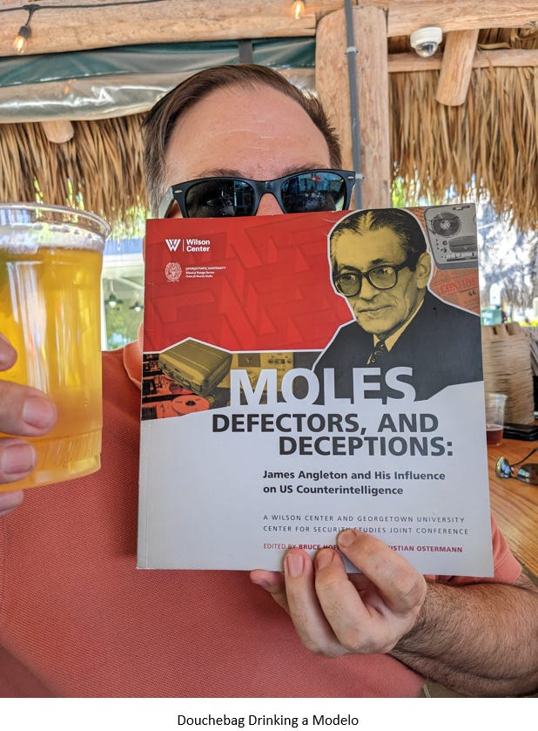](https://substackcdn.com/image/fetch/f_auto,q_auto:good,fl_progressive:steep/https%3A%2F%2Fsubstack-post-media.s3.amazonaws.com%2Fpublic%2Fimages%2Fe2b6b524-458d-4b28-9e30-46123a56c5d9_618x839.png)](https://substackcdn.com/image/fetch/f_auto,q_auto:good,fl_progressive:steep/https%3A%2F%2Fsubstack-post-media.s3.amazonaws.com%2Fpublic%2Fimages%2Fe2b6b524-458d-4b28-9e30-46123a56c5d9_618x839.png" \t "_blank)

**I like you, John....but I am certain that your taste in both beer and music is fucking shit. Budweiser and Jimmy Buffett (pbuh) is my (correct) guess. You are standard-fare 4th generation Boring-German-American, unlike my sophisticated Balkan self. I bet you have never even traveled outside of the USA, except to torture certain Arabs to get them to cough up useless information on other US intel assets.**

What happens in GTMO stays in GTMO. Well, mostly. I don’t drink much beer, when I do it’s Modelo Especial or Pilsner Urquell. My go-to is a martini, shaken not stirred: cliché, I know. Good vodka, shockingly dry, with a lemon twist (I detest olives in all forms). I like red wine, if it’s good; Croatia’s is often excellent.

My taste in music is appalling, I’ll cop to that. Not [**Margaritaville**](https://www.youtube.com/watch?v=ue2-ZVxpVjc)-appalling, however. I’m too Gen-X for Buffett and that Boomer nostalgia crap. I have a decent voice. I like karaoke. It’s the last remnant of my youthful ability to play several musical instruments pretty well.

Sidebar: I am almost certainly the only person on earth who has seen both [**Honeymoon Suite**](https://www.youtube.com/watch?v=uK0AmgDGpPo)(the Rolling Stones of Niagara Falls) and Honeymoon ([**Medeni Mjesec**](https://www.youtube.com/watch?v=Lj1yoS456mg), the Rolling Stones of Banja Luka) perform live.

**There is nothing more mysterious than blood. Paracelsus considered it a condensation of light. I believe that the Aryan, Hyperborean blood is that – but not the light of the Golden Sun, not of a galactic sun, but of the light of the Black Sun, of the Green Ray.**

BAP, is that you?

**Mel Gibson stars as a down-on-his-luck ex-NSA analyst who was turfed from the organization for being too much of an uncontrollable maverick despite his overwhelming natural talent at the job. He stumbles onto highly-incendiary classified information that proves that "Trump-Russia" was actually an MI6 frame job and tries to get it into the hands of the right people, although they are beyond his reach. He is forced to take matters into his own hands, which leads him to infiltrate the Biden Family, attaching himself to Hunter. For the next six months, he and Hunter become best friends, partying with strippers and high class escorts from Las Vegas through to NYC, and all points in between. Eventually, Mel manages to uncover Hunter's Beijing handler, but insists that he will trade the information only if his info on MI6's subterfuge can be placed in safe hands. Just before a deal is struck, he is extraordinarily renditioned to Djibouti, where a furious Joe Biden meets him to confront and threaten him, but completely forgets why he is there and what he was going to say, incoherently babbling something about some gangster named "Cornpop" instead. Rob Reiner takes command of the situation and threatens to eat Mel if he doesn't agree to not reveal who Hunter's Beijing handler is. In the nick of time, Elon Musk Starlinks himself and a team of patriotic NSA agents to whisk Mel out of there, foiling Biden's plans. A congressional investigative committee reveals Mel's information on MI6's treachery, and the USA decides to nuke London in reprisal. Would you watch this movie?**

Watch it? I feel like I’ve lived it. At least in part.

I have encountered real-world covert ops that were more far-fetched than this plotline. No, I can’t discuss them.

*You can find John Schindler polluting the timeline on Twitter/X*[***here***](https://twitter.com/20committee)*,*